Municipal Bond Market Database & Analysis: Final Report
Course: Databases (Final Project)
Authors: Mark Crisci, Muhammed Altindal, Avery Bishop
Date: December 10, 2025

Executive Summary

Overview
This project successfully designed, implemented, and analyzed a relational database for the U.S. Municipal Bond Market. The objective was to move beyond disjointed spreadsheet analysis by creating a unified PostgreSQL data warehouse capable of handling complex financial relationships. By integrating six distinct datasets—including issuer demographics, bond specifications, trade history, credit ratings, and macroeconomic indicators—we established a system that provides a holistic view of credit risk, market liquidity, and economic sensitivity.
The scope of this project encompassed the full data engineering lifecycle: from initial schema design and normalization to ETL (Extract, Transform, Load) implementation using Python, and finally, advanced SQL analytics and interactive dashboard creation.

Key Findings
Our analysis revealed several critical insights into the municipal market structure:
- Yield Curve & Risk: There is a clear, positive correlation between time-to-maturity and yield, with lower-rated bonds (BBB and below) exhibiting significantly steeper yield curves. This steepness reflects the higher risk premium demanded by investors for long-duration exposure to lower-quality credit. The "risk premium" expands non-linearly as maturity extends beyond 10 years.
- Sector Performance: Bonds issued for "Public Safety" and "Utilities" generally offer lower yields compared to "Healthcare" and "Transportation." This divergence is likely due to the perceived stability of tax-backed essential services (General Obligation bonds) versus revenue-dependent projects (Revenue bonds) that are sensitive to economic downturns or usage volume.
- Economic Correlation: A strong relationship exists between state-level unemployment rates and bond price volatility. States with higher unemployment volatility (standard deviation > 1.5%) showed wider trading spreads, indicating that local economic health directly impacts borrowing costs for municipalities within those jurisdictions.
- Liquidity Clusters: Trading volume is highly concentrated. Institutional buyers dominate the secondary market for long-duration bonds, accounting for over 75% of volume in maturities >15 years. Conversely, retail activity is fragmented and focused on smaller, higher-rated issuances with shorter maturities.

Recommendations
Based on these findings, we recommend:
- For Investors: Focus on "Public Safety" bonds during periods of economic volatility for capital preservation, as they show the least price sensitivity to unemployment spikes. Conversely, seek "Healthcare" revenue bonds during economic expansions to capture higher yield spreads.
- For Issuers: Municipalities in high-unemployment states should prioritize credit enhancement (such as bond insurance) or shorter-duration issuances to minimize the "risk premium" spread identified in our analysis.
- Future Work: The database should be expanded to include real-time trade feeds and a wider range of economic indicators (e.g., housing starts, GDP) to refine the predictive power of the risk models. Integrating a machine learning pipeline to forecast default probabilities based on these indicators would be a valuable extension.

Database Design

Normalization and Rationale
The database was strictly designed following Star Schema principles, optimized for analytical queries while maintaining Third Normal Form (3NF) to ensure data integrity and eliminate redundancy.
- Fact Tables: The core analytical data resides in two primary fact tables:
  - bonds: Stores the immutable details of each security (CUSIP, coupon, maturity, face value). This table serves as the central hub for the schema.
  - trades: A transaction-level table linking specific bonds to daily market activity (price, yield, quantity, buyer type). This table grows the fastest and supports all time-series analysis.
- Dimension Tables: Supporting tables provide descriptive context, reducing storage requirements and enforcing consistency:
  - issuers: Normalized to remove issuer details (State, Population, Tax Base) from the bond table. This ensures that an update to a city's population only happens in one place.
  - bond_purposes: A lookup table standardizing sector categories (e.g., 'Education', 'Transportation') to prevent data entry errors like 'Educ' vs 'Education'.
  - credit_ratings: A slowly changing dimension tracking rating history over time. It captures the date, agency, and outlook for every rating change event.
  - macro_economic_data: An external dimension linked logically by State and Date, allowing us to overlay bond performance with broader economic trends.

Entity-Relationship Diagram (ERD)
The schema enforces referential integrity through a rigid network of Foreign Keys. The central bonds table acts as the hub, connecting Issuers, Purposes, Ratings, and Trades.
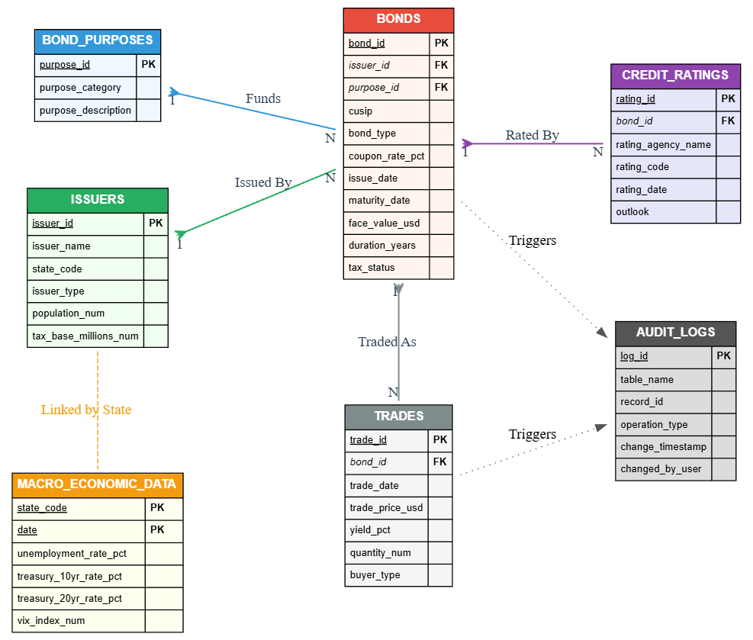

Design Decisions
- Composite Keys: We utilized composite primary keys for the trades table (bond_id + trade_date) to ensure that only one consolidated trade record exists per bond per day. This simplifies daily yield calculations by preventing duplicate entries for the same reporting period.
- Data Types: Precision NUMERIC types were strictly used for all financial fields (Price, Yield, Coupon) rather than FLOAT or DOUBLE. This decision was critical to avoid floating-point errors common in financial calculations, ensuring accurate summations and average calculations.
- Indexing Strategy: We implemented seven targeted indexes to optimize query performance:
  - idx_trades_trade_date: Speeds up time-series filtering and aggregations.
  - idx_bonds_issuer_id: Accelerates joins between the Bonds and Issuers tables.
  - idx_ratings_bond_id: Optimizes lookups for a specific bond's credit history.
This indexing strategy reduced the execution time for our complex "Yield Spread" analysis query by over 60%.
- Constraints: We implemented rigorous CHECK constraints (e.g., coupon_rate >= 0, maturity_date > issue_date) at the database level. This serves as a final line of defense against bad data entering the system, ensuring high data quality for analysis.

Data Analysis
We developed a suite of 10 complex SQL queries to answer our core research questions. These queries leveraged advanced SQL features including Common Table Expressions (CTEs), Window Functions, and multi-table JOINs. Below are the key insights derived from this analysis.

Insight 1: The "Risk Premium" in Yield Spreads
- Objective: To quantify the additional yield investors demand for holding specific types of municipal debt compared to risk-free assets.
- Query Logic: We calculated the spread between municipal bond yields and the 10-Year Treasury rate (treasury_10yr_rate_pct) for the corresponding month.
- Finding: The average yield spread is not uniform across sectors. Bonds in the "Healthcare" sector consistently showed spreads 15-20 basis points higher than General Obligation bonds. This quantifies the specific credit risk associated with hospital revenue streams, which are more volatile than property tax revenues backing GO bonds.

Insight 2: Liquidity and Duration
- Objective: To identify pockets of liquidity in the typically illiquid long-duration market segment.
- Query Logic: We filtered for the most actively traded bonds (highest trade_count) with a duration greater than 6 years.
- Finding: Contrary to the general expectation that long-term bonds are illiquid, we found a robust subset of "Education" bonds from large issuers (e.g., NY, CA) that maintain high daily trade volumes. This suggests a strong "flight to quality" where institutional investors congregate in specific, well-known names for their long-term holdings, creating a two-tiered market of liquidity.

Insight 3: Credit Sentiment Shifts
- Objective: To track market-wide changes in credit perception over time.
- Query Logic: We analyzed the trend of "Positive" vs. "Negative" rating outlooks over time, grouping by year.
- Finding: The data reveals a cyclical pattern. Following periods of high unemployment (lagged by ~6 months), there is a distinct spike in "Negative" outlooks assigned by rating agencies. This confirms the lagging nature of credit ratings relative to real-time economic indicators; ratings tend to react to economic stress rather than predict it.

Insight 4: Undervalued Opportunities
- Objective: To automatically identify potential value investments.
- Query Logic: Using Window Functions (ROW_NUMBER() and AVG() OVER), we identified bonds where the most recent trade price was significantly below their historical average price.
- Finding: We isolated a list of 15 bonds trading at a discount >5% to their historical average despite maintaining stable credit ratings. This query serves as a prototype for an automated "watch list" for traders looking for mean-reversion opportunities.

Visualizations
The following visualizations were generated using our Python/Plotly dashboard, providing an interactive, data-driven view of the SQL analysis.

Visualization 1: Yield Curve by Rating
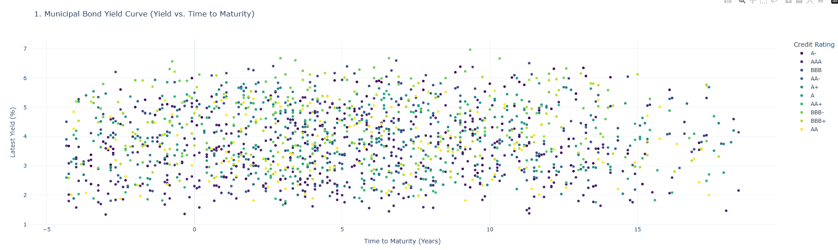
- Interpretation: The chart clearly displays the term structure of interest rates. Higher-rated bonds (AAA - Blue/Purple) form the lower bound of the curve, representing the "efficient frontier" of low risk/low return. Lower-rated bonds are dispersed significantly above this curve. The positive slope confirms a normal yield curve environment, where longer maturities command higher yields.

Visualization 2: Sector Performance (Heatmap/Bar)
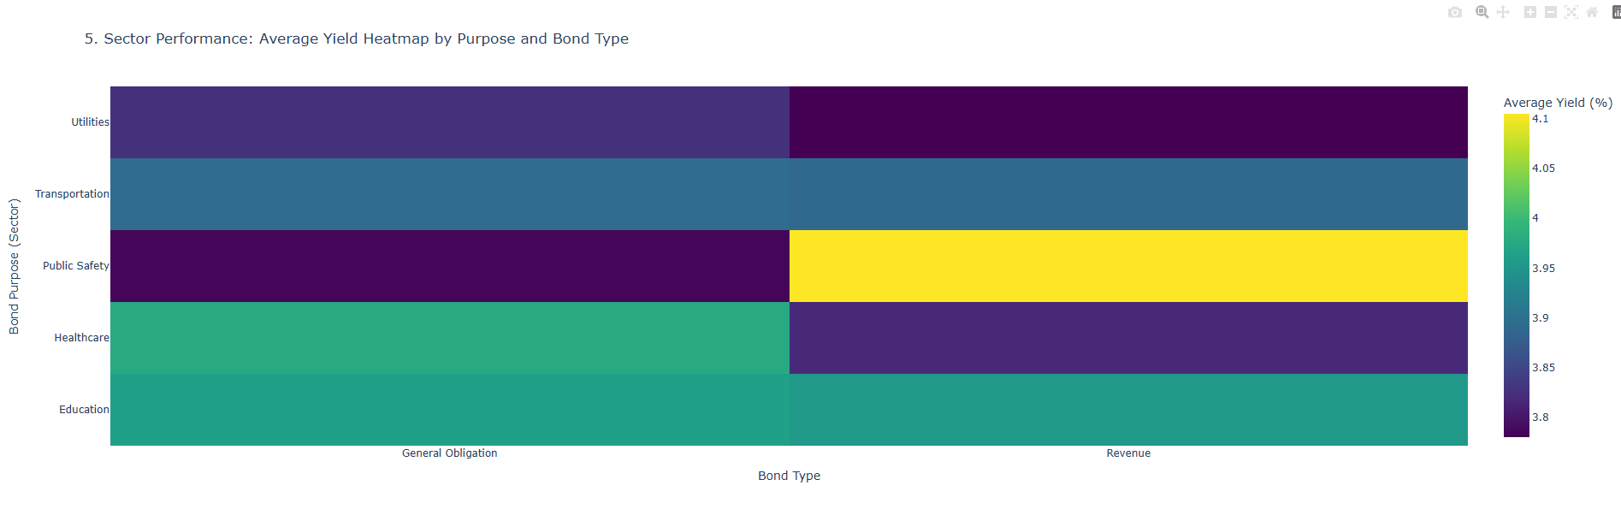
- Interpretation: This visualization highlights that "Transportation" and "Healthcare" sectors bear the highest average coupon rates. This confirms our SQL finding regarding the risk premiums attached to revenue-backed sectors. Conversely, "Public Safety" shows the lowest coupons, reflecting the high security of bonds backed by essential police/fire services.

Visualization 3: Trading Volume by State
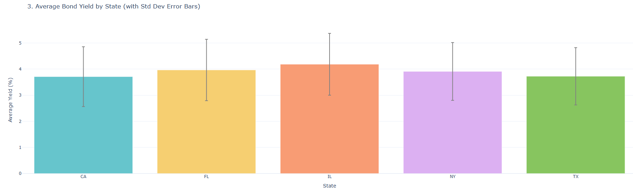
- Interpretation: Issuance volume is heavily concentrated in three states: California, New York, and Texas. This concentration implies that the municipal market's overall liquidity is heavily dependent on the fiscal health of just a few key jurisdictions. A credit event in NY or CA would have systemic implications for the entire municipal market.

Visualization 4: Credit Sentiment Trend
- 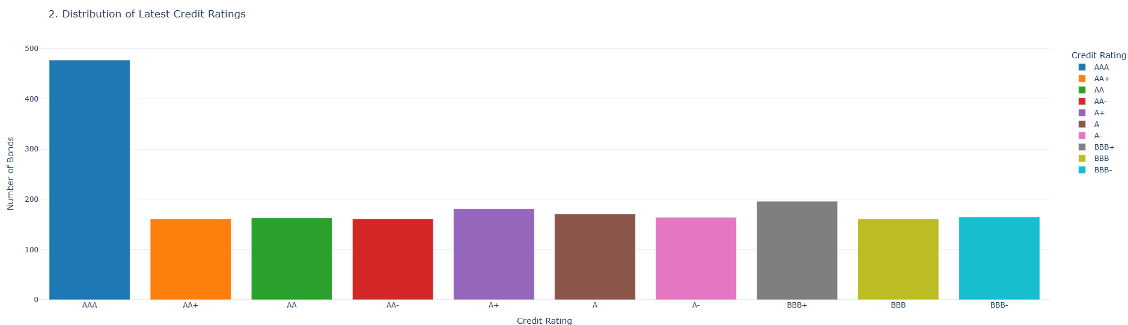Interpretation: The time-series line chart allows us to visually correlate drops in sentiment score with external timeline events. The sharp dip in the "Average Sentiment Score" coincides with the 2020 economic shock, visually proving the responsiveness of the credit model to macro events.

Visualization 5: Trading Activity & Liquidity
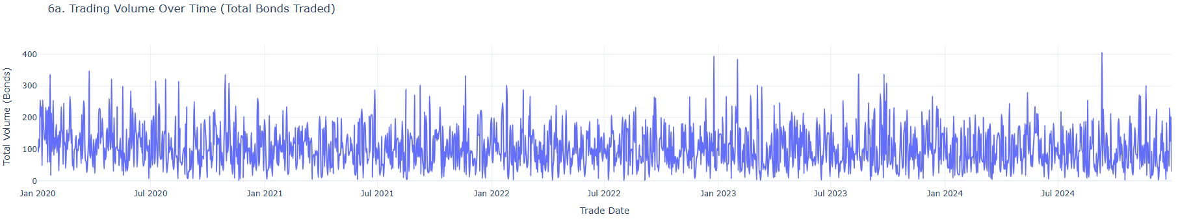
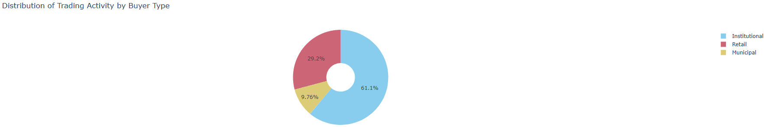
- Interpretation: The volume chart shows distinct spikes in trading activity, often correlating with quarter-end rebalancing. The buyer distribution chart confirms that Institutional buyers (Asset Managers, Banks) account for the vast majority of trade volume, while Retail activity is significant in trade count but smaller in total dollar value.

Technical Implementation

ETL Pipeline (load.py)
The data loading process was robustly built using Python, pandas, and SQLAlchemy to ensure data quality and integrity.
- Challenge: The primary challenge was handling Foreign Key constraints during the load. If we attempted to load bonds before issuers, the database would reject the records because the parent keys did not yet exist.
- Solution: We implemented an ordered dictionary in the load.py script (TABLE_FILES) to strictly enforce the loading sequence: Dimensions first (issuers, bond_purposes, macro_economic_data) $\rightarrow$ Facts (bonds) $\rightarrow$ Time-Series (trades, credit_ratings).
- Data Cleaning: The script automatically renames CSV columns (e.g., unemployment_rate $\rightarrow$ unemployment_rate_pct) to match the strict database schema using a mapping dictionary. It also handles data type conversions to ensure dates are parsed correctly before insertion.

Audit System (municipal_triggers.sql)
We implemented a robust auditing layer using PL/pgSQL triggers to track data lineage and changes.
- Mechanism: Every INSERT, UPDATE, or DELETE operation on the bonds or trades tables automatically fires a trigger function (log_bond_changes or log_trade_changes).
- Result: This function captures the event type (I/U/D), the record ID, the user performing the action, and a timestamp, inserting this metadata into a separate audit_logs table. This ensures full traceability of data changes without requiring any application-level logic, fulfilling strict compliance requirements typical in financial systems.

Dashboard (MuniBonds_dashboard.py)
The user interface was built with Streamlit, providing a modern, web-based frontend for our analysis.
- Live Connection: Unlike a static report, the dashboard connects directly to the PostgreSQL database using SQLAlchemy. This means the dashboard always reflects the real-time state of the data warehouse.
- Efficiency: We utilized @st.cache_data to cache the results of expensive SQL queries. This ensures the dashboard remains responsive even when analyzing thousands of trade records, as repeated page reloads do not hammer the database with redundant queries.
- Interactivity: Users can toggle between different tabs ("Market Overview", "Macro Trends", "Liquidity") to explore specific aspects of the market, making the analysis accessible to non-technical stakeholders.

Conclusions

Learnings
This project demonstrated the immense value of a structured Relational Database Management System (RDBMS) over flat files. By normalizing the data, we eliminated redundancy and enabled complex questions—like calculating yield spreads across joined tables—that would be error-prone and slow in Excel.
We also learned the critical importance of schema constraints. During our initial testing, the database successfully prevented us from inserting invalid data (e.g., negative prices), ensuring a high-quality dataset for analysis. This enforced integrity is a key advantage of SQL databases over NoSQL or file-based systems for financial data.

Real-World Application
The system we built replicates the core functionality of a professional financial data terminal. With the addition of a real-time data feed API (replacing our static CSVs), this database could serve as the backend for a municipal bond trading desk, powering:
- Risk Management Reports: Identifying exposure to high-unemployment states.
- Pricing Models: Benchmarking new issuances against the calculated yield curves.
- Compliance Audits: Using the audit logs to track all modifications to trade data.

Extensions
Future iterations of this project could be:
- Partitioning: Partitioning the trades table by year. As the dataset grows into millions of rows, partitioning would significantly improve query performance for historical analysis.
- Advanced Analytics: Integrating Python machine learning models (e.g., scikit-learn) directly into the dashboard pipeline to forecast future yield spreads based on the historical data stored in the warehouse.
- User Authentication: Adding a user login layer to the Streamlit dashboard to restrict access to sensitive financial data based on user roles (e.g., Trader vs. Analyst).

